September 2025
Programme 2025 - 2026
3rd | Opening night drinks and nibbles. Meet and greet new members |  | Presentation - members show a sample of their images – please bring images.  Please bring food for the buffet
10th | Dave Murrell ‘Carp Diem’ |  | murrellda@gmail.com‘
17th | Denis Dunning |  | An interactive evening – what are judges looking for?
25th | Peter Downs |  | Adventures in Abstract
October 2025
1st | Ist Competition |  | Judge – David Boath
8th | Alan Brown |  | Street Photography  https:/reversingmirror.co.uk
15th | Interclub Competition with Hartlepool |  | Hosted by Stockton CC  Judge – Stephen Fowler
22nd | 2nd Competition Theme – ‘Looking Up’ |  | Judge – Graeme Clarke
 | Print Clinic
  29th | John Illingworth | Woodland – It’s not just trees
November 2025
5th | Practical Night
12th | TBA
19th | Norton Tankard Competition |  | Members submit a panel of  images [3,4,or 5] on their  chosen theme  Judge -Rob Butler
26th | Michael Forrester |  | Just Wildlife
December 2025
3th | NYSDPA Inter Club Portfolio |  |  |  | A chance to see club entries
10th | NCPF Portfolio |  |  |  | A chance to see entries in the regional competition
18th | Christmas Party – quiz and buffet |  |  |  | Please bring food for the buffet
January 2025
7th | 3rd Competition |  |  |  | Judge – Dave Philips
14th | Software night
21st | NYSDPA Silver Salver Portfolio |  |  |  | A chance to see club entries in the regional competition
28th | Les Forrester  BA Hons Photo, ARPS |  |  |  | The Art In Architecture  www.lesforrester.com/about me
February 2026
4th | 4th Competition  Theme ‘Reflective@ |  |  |  | Judge = Peter Maguire
11th | AV Night |  |  |  | Members bring in their own presentations
18th | Its a Knockout |  |  |  | Members to submit 4 digital images to be judged by members
25th | Bingo Challenge |  |  |  | Images from members on random theme
March 2026
4th |  | 5th Competition |  |  | Open Competition  Judge – Dave Murrell
11th |  | Linda Golightly |  |  | Photographic Critique  www.whickhamphoto-graphic.club
18th |  | Practical night/print clinic
25th |  | Joseph Duffy ARPS |  |  | Chasing the Light
April 2026
1st | Image of the Year competition |  |  | Judge – Dave Coates
8th | AGM
15th | Presentation Evening
Competition details
 | Date for Entries |  |  |  | Judging Date
1st Competition
 | 10/09/2025 |  |  |  | 1/10/2025
Interclub Competition
 | 24/9/2025 |  |  |  | 15/10/2025
2nd Competition – theme ‘Curves’
 | 1/10/2025 |  |  |  | 22/10/2025
Norton Tankard
 | 29/10/2025 |  |  |  | 19/11/2025
3rd Competition
 | 10/12/2025 |  |  |  | 7/1/2026
4th Competition – theme ‘Reflective’
 | 14/01/2026 |  |  |  | 4/2/2026
5th Competition
 | 11/02/2026 |  |  |  | 4/3/2026
Print and Digital Image of the Year
 | 11/03/2026 |  |  |  | 1/4/2026
Hand in date for: NYSDPA Competition TBA
NCPF Competition TBA
Meetings are held between 7.30 and 9.30 at:
Room 3
Elmwood Community Centre
53 Darlington Road
Hartburn
Stockton-on-Tees
TS18 5EP

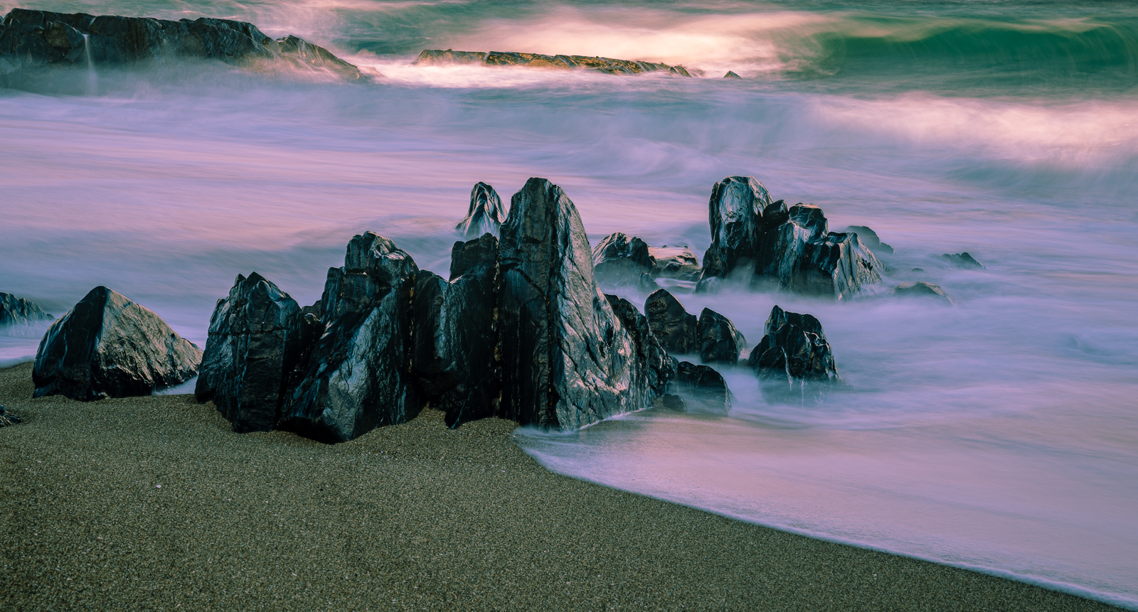
For more details call Steve Smith on 01642 588604 or email on s.smith440@me.com
Frank Adams– Digital Image of the Year 2024 -2025

Welcome to Stockton Camera Club
If you enjoy photography – whether taking photographs or simply looking at them, why not come along to our Club?
We have people of all levels of expertise as members, both experienced and novice photographers. No matter what your favourite subject matter or the equipment you use, be it medium format or compact camera, film or digital, if you enjoy taking or looking at photographs, or want to become more proficient at taking them, you will find something to interest you.
We have a full and varied programme of meetings throughout the year including illustrated talks by leading photographers and competitions where independent judges give advice on our efforts.
Members are encouraged to show their images and to demonstrate new techniques or share problems encountered when trying to enhance those ‘difficult’ images. Many of our more experienced members give help on the various methods of enhancing images by digital means.
The club members welcome everyone who comes along. The centre is open from 7.15 with a 7.30 start. The sessions finish at 9.30 with a ten minute tea break. We look forward to meeting you.

Steve Smith
Monochrome
Image of the Year

Club Officers
Life Vice President
Chair | Steve Smith LRPS
Vice Chair | Sarah Hillier LRPS
Secretary | Sue Tyerman LRPS
Treasurer | Sue Tyerman LRPS
Competition Secretary | Brian Swales LRPS
Programme Secretary | Steve Smith LRPS
Publicity Officer | Vacancy
Committee Members | Ken Messham
 | Carmel Morris ARPS
 | Matt Kerridge
Ladder Competition Secretary | Darren Richardson
Projectionist | Ken Messham
Deputy Projectionist | Andy Gunn
NCPF Representative | Darren Richardson
NYSDPA Representative | Andy Gunn
Webmaster | Brian Swales LRPS
Webmaster | Sue Tyerman LRPS
Stockton
Camera
Club

Programme
2023 -2024
www.stockton cameraclub.co.uk

Life Vice President
Chair | Steve Smith LRPS
Vice Chair | Sarah Hillier LRPS
Secretary | Sue Tyerman LRPS
Treasurer | Sue Tyerman LRPS
Competition Secretary | Brian Swales LRPS
Programme Secretary | Steve Smith LRPS
Publicity Officer | Vacancy
Committee Members | Ken Messham
 | Carmel Morris ARPS
 | Matt Kerridge
Ladder Competition Secretary | Darren Richardson
Projectionist | Ken Messham
Deputy Projectionist | Andy Gunn
NCPF Representative | Darren Richardson
NYSDPA Representative | Andy Gunn
Webmaster | Brian Swales LRPS
Webmaster | Sue Tyerman LRPS
Stockton
Camera
Club

Programme
2023 -2024
www.stockton cameraclub.co.uk

Life Vice President
Chair | Steve Smith LRPS
Vice Chair | Sarah Hillier LRPS
Secretary | Sue Tyerman LRPS
Treasurer | Darren Richardson
Competition Secretary | Darren Richardson
Programme Secretary | Steve Smith LRPS
Publicity Officer | Vacancy
Committee Members | Ken Messham
 | Steven Bailey
 | Brian Swales
 | Matt Kerridge
Ladder Competition Secretary | Darren Richardson
Projectionist | Ken Messham
Deputy Projectionist | Paul Kent
NCPF Representative | Darren Richardson
NYSDPA Representative | Andy Gunn
Webmaster | Brian Swales LRPS
Webmaster | Sue Tyerman LRPS
Tea Joanne Smith
To contact the club
Call Steve Smith om 01642 588604
Email s.smith440@me.com
Subscription

Ordinary Member £60
Member and Partner £70
Senior Citizen £50
Junior and Job Seeker Allowance £35

The above subscriptions are inclusive of membership of the NCPF andNYSDPA

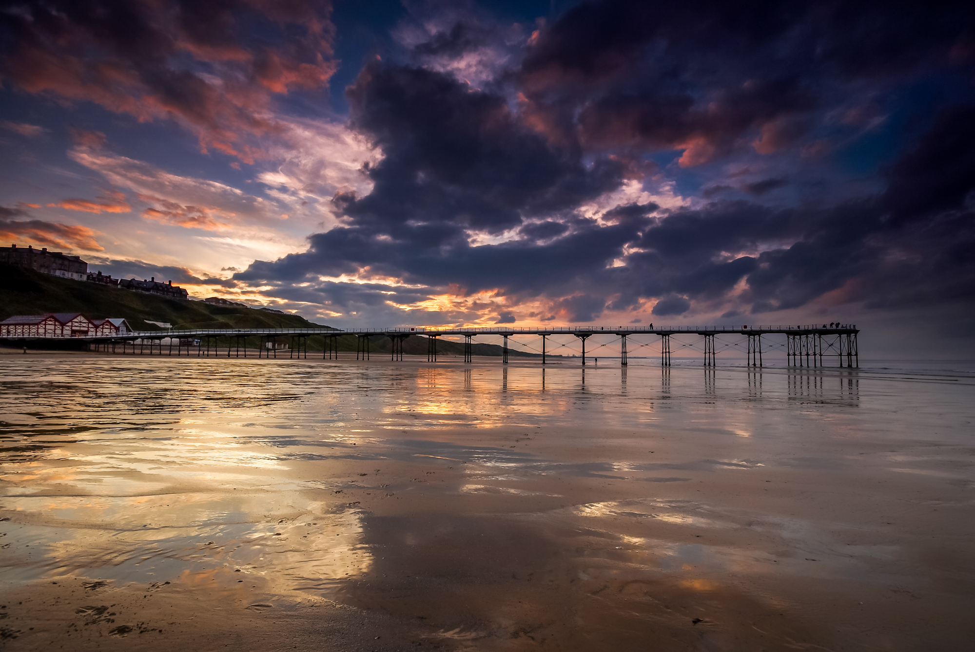
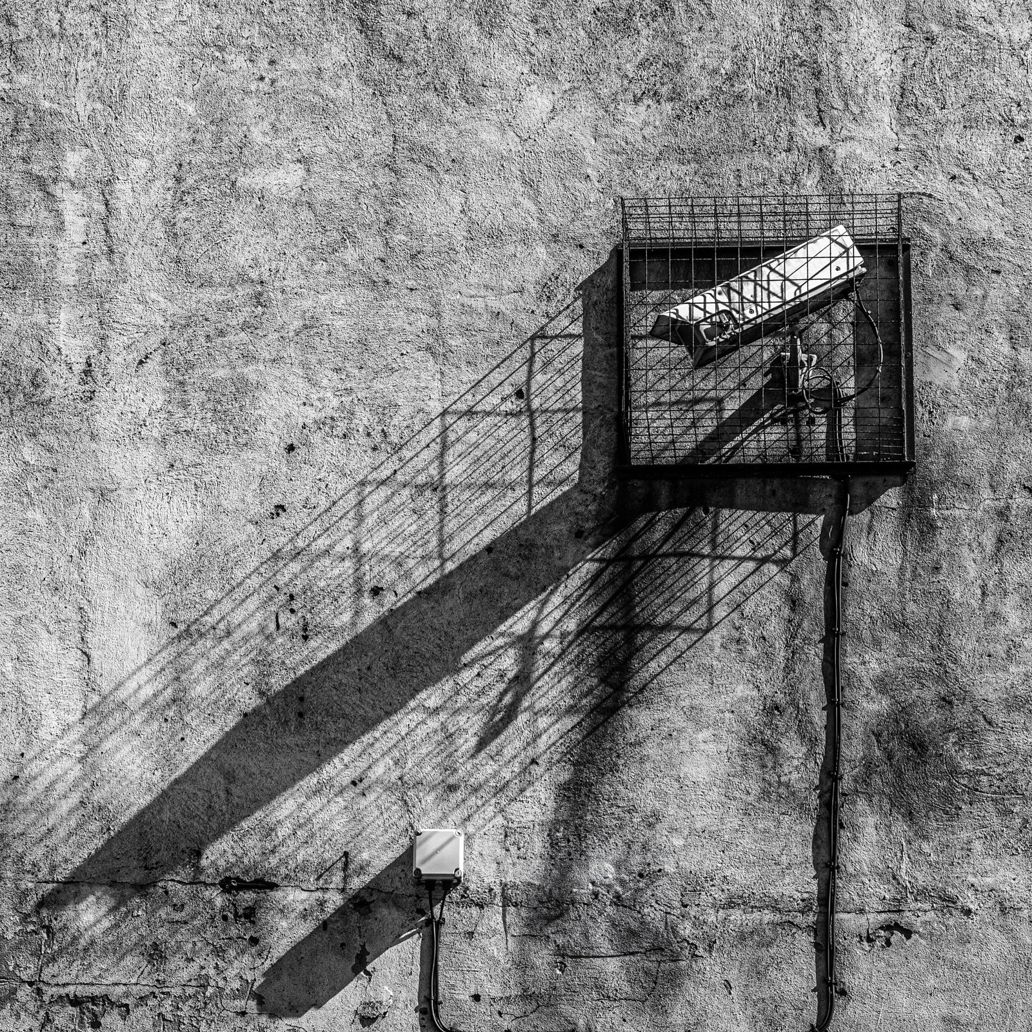
Welcome to Stockton Camera Club
If you enjoy photography – whether taking photographs or simply looking at them, why not come along to our Club?We have people of all levels of expertise as members, both experienced and novice photographers. No matter what your favourite subject matter or the equipment you use, be it medium format or compact camera, film or digital, if you enjoy taking or looking at photographs, or want to become more proficient at taking them, you will find something to interest you.
We have a full and varied programme of meetings throughout the year including illustrated talks by leading photographers and competitions where independent judges give advice on our efforts.
Members are encouraged to show their images and to demonstrate new techniques or share problems encountered when trying to enhance those ‘difficult’ images. Many of our more experienced members give help on the various methods of enhancing images by digital means.
The club members welcome everyone who comes along. The centre is open from 7.15 with a 7.30 start. The sessions finish at 9.30 with a ten minute tea break. We look forward to meeting you.
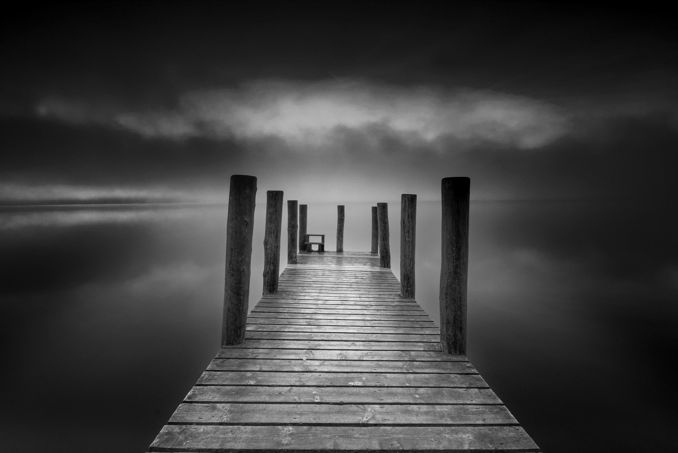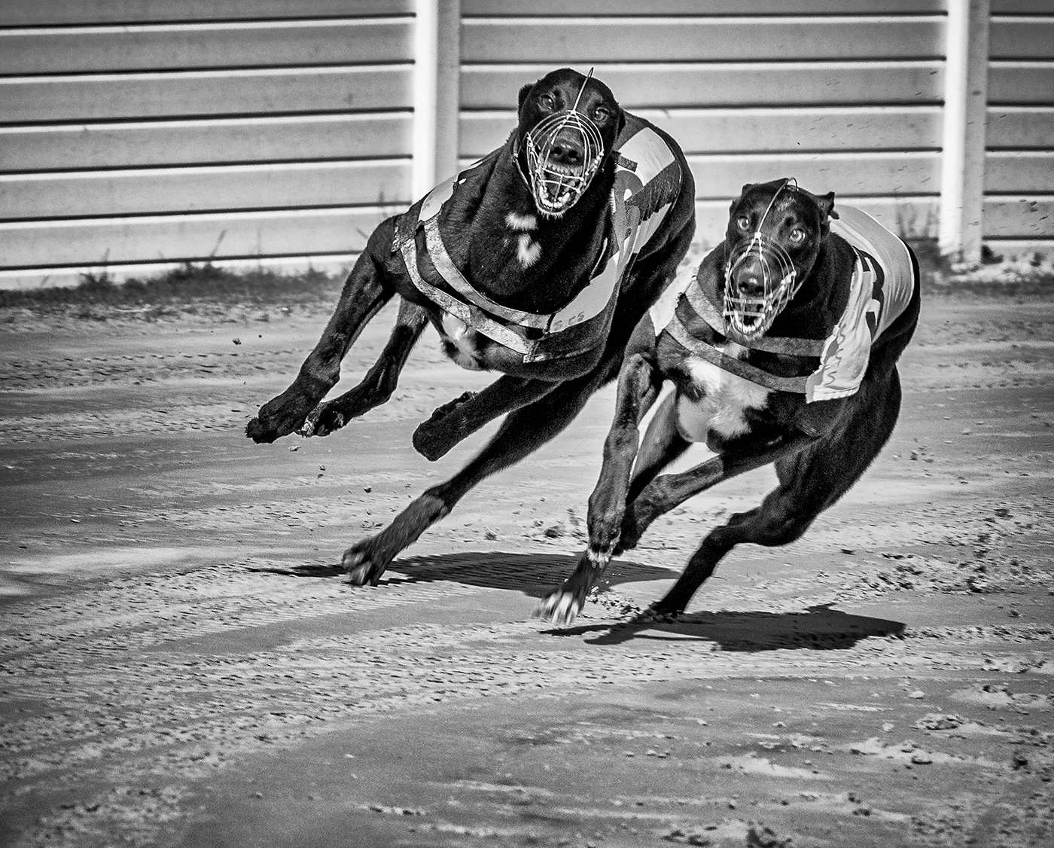

Dave Hudspeth – Colour Image of the Year
Steve Smith - Monochrome Image of the Year 2024-2025
Stockton

Camera

Club

Programme

2025 – 2026

www.stocktoncameraclub.co.uk

