September 2026
Programme 2026 - 2027
2nd | Opening night drinks and nibbles. Meet and greet new members |  | Presentation - members show a sample of their images – please bring images.  Please bring food for the buffet
9th | David Stout,  EPSA,EFIAP,DPAGB. |  | "Travel Photography My Way”  https://www.whickhamphoto graphic.club/project/david stout/
16th | Veronica Congleton ARPS |  | Travelling Light  www.pontelandphotographicsociety .co.uk/members/veronica congleton-lrps/
23th | Sue Hingley |  | Discovering Cuba
30th | Ist Competition |  | Judge – Stephen Fowler  open
October 2026
7th | Dave Dixon |  | Photographing the urban landscape
12h | Interclub Competition with Hartlepool |  | Hosted by Hartlepool CC  Judge –
21st | Tom Hill |  | Light Painting  https://lightpaintingparadise. com/en/tom-hill/
 | 2nd Competition |  | Judge – Linda Golightly  Theme – ‘Weathered and Worn
  28th | John Illingworth  Steve Smith -The Climb  Colour image of the Year 2025-2026 | Woodland – It’s not just trees
November 2026
4th | Practical Night
11th | Photo Critique Night
18th | Norton Tankard Competition |  | Judge – Alan Wilsom  embers submit a panel of  images [3,4,or 5] on their  chosen theme  Judge -
25th | Harry Hall |  | Beyond Street Photography
December 2026
2nd | NYSDPA annual competition |  |  |  | A chance to see club entries
9th | NCPF Portfolio |  |  |  | Selection of images from 2025 competition
16th | Christmas Party – quiz and buffet |  |  |  | Please bring food for the buffet
January 2027
6th | 3rd Competition |  |  |  | Judge – Rob Butler
13th | Photo Critique night |  |  |  | Members discuss images
20th | NYSDA Silver Salva Portfolio |  |  |  | A chance to see club entries in the regional competition
27th | Alan Porrett |  |  |  | Curious Northumbria  https://www.porrett.org/ about.html Curious Northumbria
February 2027
3rd | 4th Competition |  |  |  | Judge – Albert Wood  Theme ‘The low Angle’
10th | AV Night |  |  |  | Members bring in their own presentations
17th | Software Night |  |  |  | Members to submit 4 digital
24th | Bingo Challenge |  |  |  | Images from members on random theme
March 2027
3rd |  | 5th Competition |  |  | Judge – Olivia Costello  Open Competition
10th |  | London Salon of Photography |  |  | Selection of Images
17th |  | Photo Critique Night Practical |  |  | Members discuss images
24th |  | Rob Butler |  |  | Drone Photography
31st |  | Image of the Year competition |  |  | Judge -
April 2027
7th | AGM
14th | Buffet and Presentation |  |  | Please bring food for the buffet
Competition details
 | Date for Entries |  |  |  | Judging Date
1st Competition
 | 9/9/2026 |  |  |  | 30/09/2026
Interclub Competition
 | 23/9/2026 |  |  |  | 12/10/2026
2nd Competition – theme Curves’
 | 30/9/2026 |  |  |  | 28/10/2026
Norton Tankard
 | 28/10/2026 |  |  |  | 18/11/2026
3rd Competition
 | 2/12/2026 |  |  |  | 6/1/2027
4th Competition – theme ‘Reflective’
 | 13/01/2027 |  |  |  | 3/2/2027
5th Competition
 | 10/2/2027 |  |  |  | 3/3/2027
Print and Digital Image of the Year
 | 30/10/27 |  |  |  | 31/3/2027
Hand in date for: NYSDPA Competition TBA
NCPF Competition TBA
Meetings are held between 7.30 and 9.30 at:
Room 3
Elmwood Community Centre
53 Darlington Road
Hartburn
Stockton-on-Tees
TS18 5EP

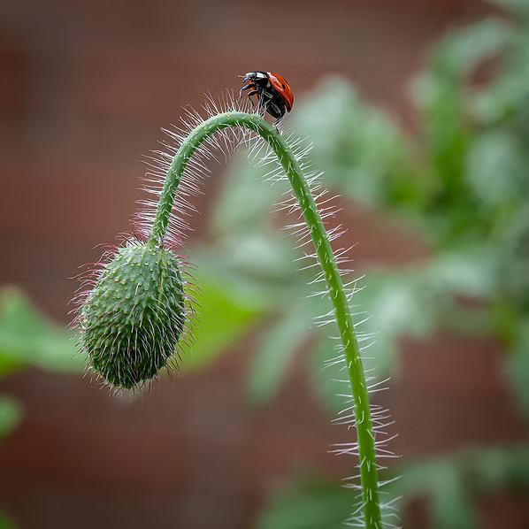
For more details call Steve Smith on 01642 588604 or email on s.smith440@me.comFrank
Club Officers
Life Vice President
Chair | Steve Smith LRPS
Vice Chair | Sarah Hillier LRPS
Secretary | Sue Tyerman LRPS
Treasurer | Darren Richardson
Competition Secretary | Darren Richardson
Programme Secretary | Steve Smith LRPS
Publicity Officer | Vacancy
Committee Members | Ken Messham
 | Steven Bailey
 | Brian Swales
 | Matt Kerridge
Ladder Competition Secretary | Darren Richardson
Projectionist | Ken Messham
Deputy Projectionist | Paul Kent
NCPF Representative | Darren Richardson
NYSDPA Representative | Andy Gunn
Webmaster | Brian Swales LRPS
Webmaster | Sue Tyerman LRPS
Tea Joanne Smith
To contact the club
Call Steve Smith om 01642 588604
Email s.smith440@me.com
Club Officers
Life Vice President
Chair | Steve Smith LRPS
Vice Chair | Sarah Hillier LRPS
Secretary | Sue Tyerman LRPS
Treasurer | Sue Tyerman LRPS
Competition Secretary | Brian Swales LRPS
Programme Secretary | Steve Smith LRPS
Publicity Officer | Vacancy
Committee Members | Ken Messham
 | Carmel Morris ARPS
 | Matt Kerridge
Ladder Competition Secretary | Darren Richardson
Projectionist | Ken Messham
Deputy Projectionist | Andy Gunn
NCPF Representative | Darren Richardson
NYSDPA Representative | Andy Gunn
Webmaster | Brian Swales LRPS
Webmaster | Sue Tyerman LRPS
Club Officers
Life Vice President
Chair | Steve Smith LRPS
Vice Chair | Sarah Hillier LRPS
Secretary | Sue Tyerman LRPS
Treasurer | Sue Tyerman LRPS
Competition Secretary | Brian Swales LRPS
Programme Secretary | Steve Smith LRPS
Publicity Officer | Vacancy
Committee Members | Ken Messham
 | Carmel Morris ARPS
 | Matt Kerridge
Ladder Competition Secretary | Darren Richardson
Projectionist | Ken Messham
Deputy Projectionist | Andy Gunn
NCPF Representative | Darren Richardson
NYSDPA Representative | Andy Gunn
Webmaster | Brian Swales LRPS
Webmaster | Sue Tyerman LRPS
Stockton
Camera
Club

Programme
2023 -2024
www.stockton cameraclub.co.uk

Welcome to Stockton Camera Club
If you enjoy photography – whether taking photographs or simply looking at them, why not come along to our Club?
We have people of all levels of expertise as members, both experienced and novice photographers. No matter what your favourite subject matter or the equipment you use, be it medium format or compact camera, film or digital, if you enjoy taking or looking at photographs, or want to become more proficient at taking them, you will find something to interest you.
We have a full and varied programme of meetings throughout the year including illustrated talks by leading photographers and competitions where independent judges give advice on our efforts.
Members are encouraged to show their images and to demonstrate new techniques or share problems encountered when trying to enhance those ‘difficult’ images. Many of our more experienced members give help on the various methods of enhancing images by digital means.
The club members welcome everyone who comes along. The centre is open from 7.15 with a 7.30 start. The sessions finish at 9.30 with a ten minute tea break. We look forward to meeting you.
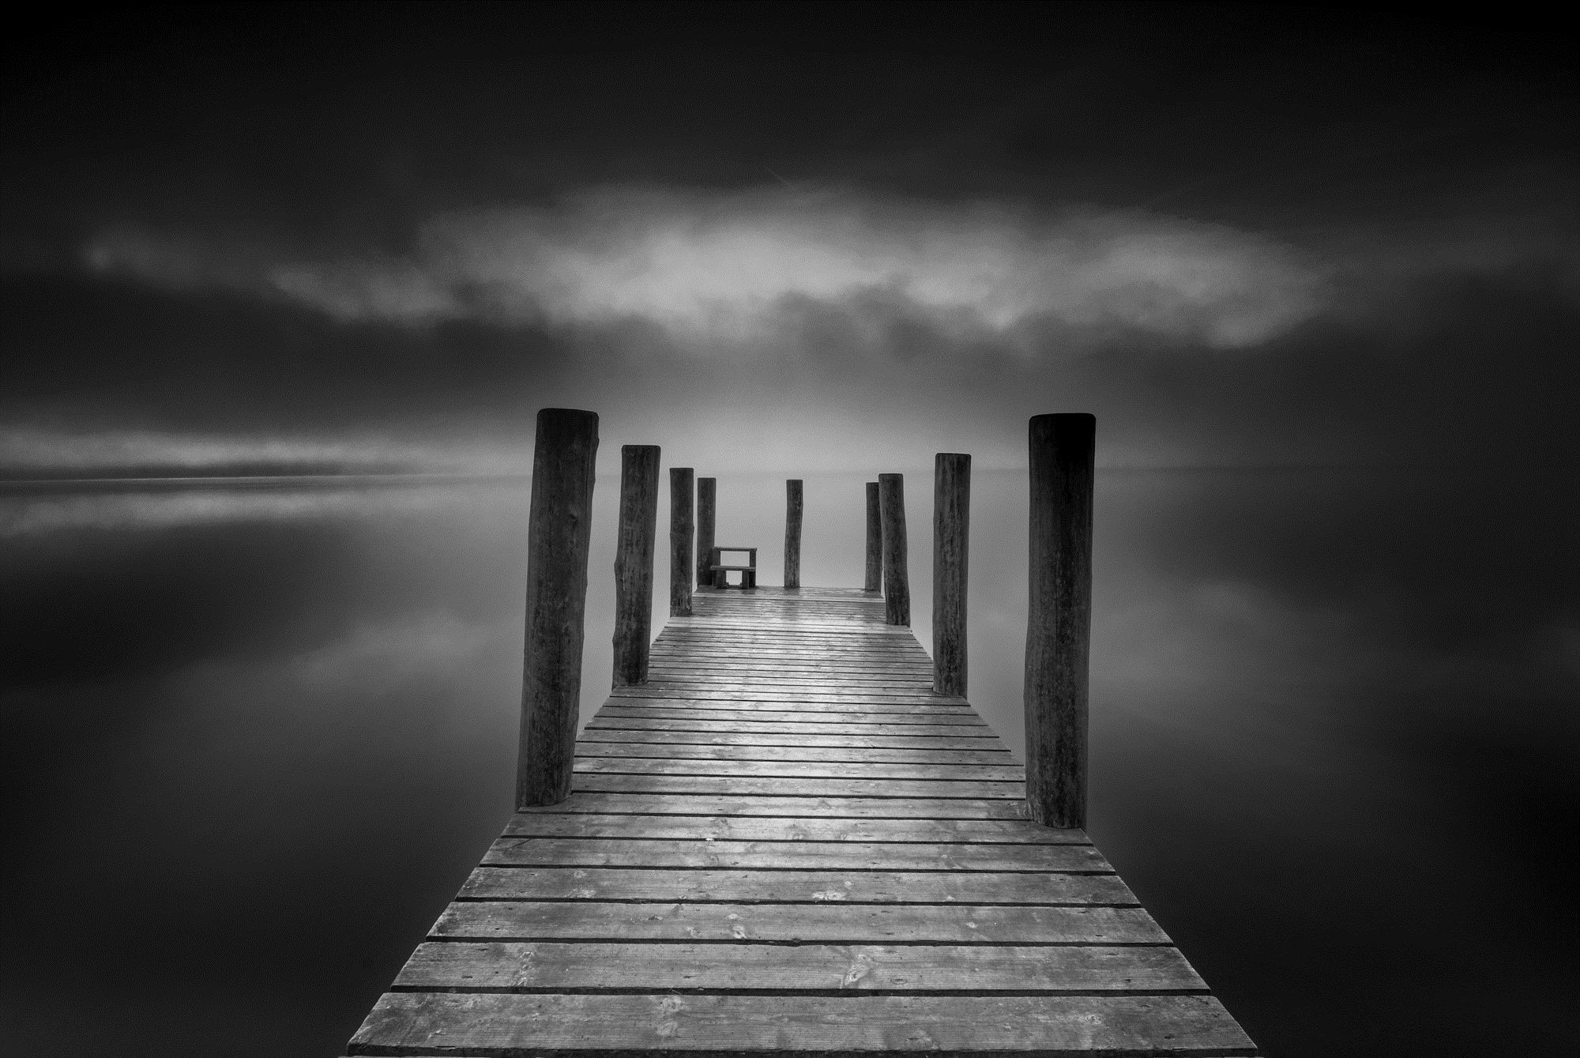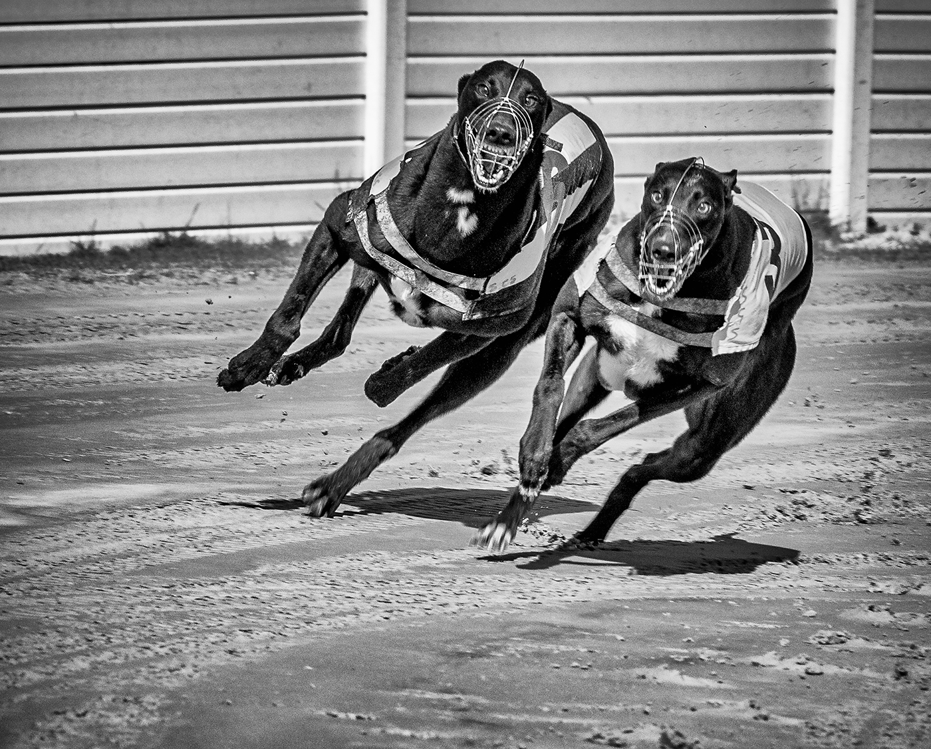

Club Officers
Life Vice President
Chair | Steve Smith LRPS
Vice Chair | Sarah Hillier LRPS
Secretary | Sue Tyerman LRPS
Treasurer | Darren Richardson
Competition Secretary | Darren Richardson
Programme Secretary | Steve Smith LRPS
Publicity Officer | Vacancy
Committee Members | Ken Messham
 | Steven Bailey
 | Brian Swales
 | Matt Kerridge
Ladder Competition Secretary | Darren Richardson
Projectionist | Ken Messham
Deputy Projectionist | Paul Kent
NCPF Representative | Darren Richardson
NYSDPA Representative | Andy Gunn
Webmaster | Brian Swales LRPS
Webmaster | Sue Tyerman LRPS
Tea Joanne Smith
To contact the club
Call Steve Smith on 01642 588604
Email s.smith440@me.com
Club Officers
Life Vice President
Chair | Steve Smith LRPS
Vice Chair | Sarah Hillier LRPS
Secretary | Sue Tyerman LRPS
Treasurer | Sue Tyerman LRPS
Competition Secretary | Brian Swales LRPS
Programme Secretary | Steve Smith LRPS
Publicity Officer | Vacancy
Committee Members | Ken Messham
 | Carmel Morris ARPS
 | Matt Kerridge
Ladder Competition Secretary | Darren Richardson
Projectionist | Ken Messham
Deputy Projectionist | Andy Gunn
NCPF Representative | Darren Richardson
NYSDPA Representative | Andy Gunn
Webmaster | Brian Swales LRPS
Webmaster | Sue Tyerman LRPS
Club Officers
Life Vice President
Chair | Steve Smith LRPS
Vice Chair | Sarah Hillier LRPS
Secretary | Sue Tyerman LRPS
Treasurer | Sue Tyerman LRPS
Competition Secretary | Brian Swales LRPS
Programme Secretary | Steve Smith LRPS
Publicity Officer | Vacancy
Committee Members | Ken Messham
 | Carmel Morris ARPS
 | Matt Kerridge
Ladder Competition Secretary | Darren Richardson
Projectionist | Ken Messham
Deputy Projectionist | Andy Gunn
NCPF Representative | Darren Richardson
NYSDPA Representative | Andy Gunn
Webmaster | Brian Swales LRPS
Webmaster | Sue Tyerman LRPS
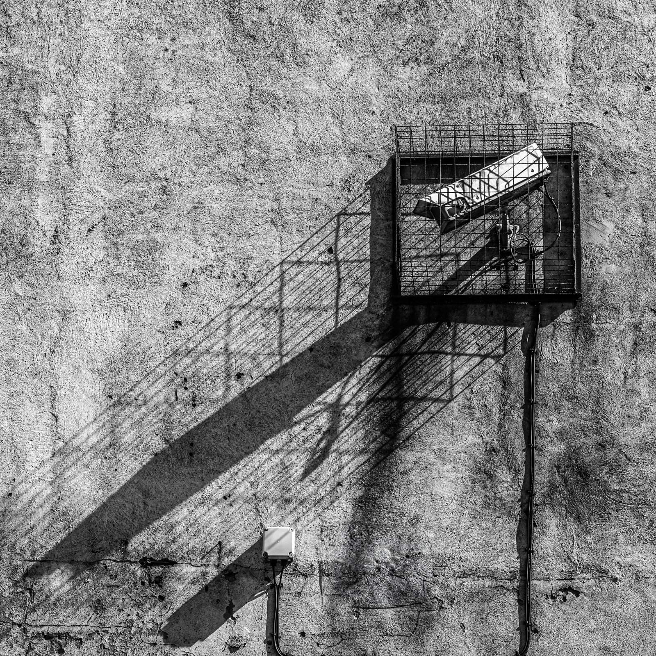
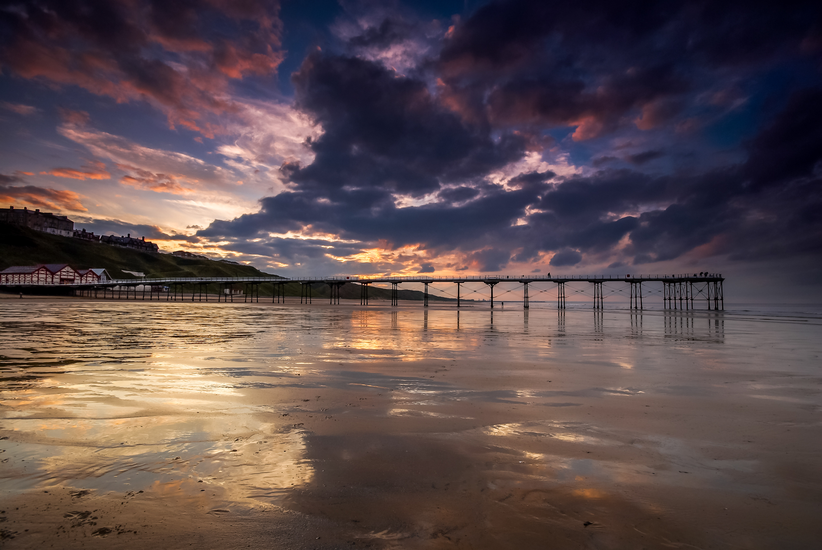
Steve Smith - Monochrome Image of the Year 2024-2025

Stockton

Camera

Club

Programme

2025 – 2026

www.stocktoncameraclub.co.uk

Dave Hudspeth – Colour Image of the Year

Club Officers
Life Vice President
Chair | Steve Smith LRPS
Vice Chair | Sarah Hillier LRPS
Secretary | Sue Tyerman LRPS
Treasurer | Darren Richardson
Competition Secretary | Darren Richardson
Programme Secretary | Steve Smith LRPS
Publicity Officer | Vacancy
Committee Members | Ken Messham
 | Steven Bailey
 | Brian Swales
 | Matt Kerridge
Ladder Competition Secretary | Darren Richardson
Projectionist | Ken Messham
Deputy Projectionist | Paul Kent
NCPF Representative | Darren Richardson
NYSDPA Representative | Andy Gunn
Webmaster | Brian Swales LRPS
Webmaster | Sue Tyerman LRPS
Tea Joanne Smith
To contact the club
Call Steve Smith om 01642 588604
Email s.smith440@me.com
Club Officers
Life Vice President
Chair | Steve Smith LRPS
Vice Chair | Sarah Hillier LRPS
Secretary | Sue Tyerman LRPS
Treasurer | Sue Tyerman LRPS
Competition Secretary | Brian Swales LRPS
Programme Secretary | Steve Smith LRPS
Publicity Officer | Vacancy
Committee Members | Ken Messham
 | Carmel Morris ARPS
 | Matt Kerridge
Ladder Competition Secretary | Darren Richardson
Projectionist | Ken Messham
Deputy Projectionist | Andy Gunn
NCPF Representative | Darren Richardson
NYSDPA Representative | Andy Gunn
Webmaster | Brian Swales LRPS
Webmaster | Sue Tyerman LRPS
Life Vice President
Chair | Steve Smith LRPS
Vice Chair | Sarah Hillier LRPS
Secretary | Bridgette Thomasson
Treasurer | Darren Richardson
Competition Secretary | Darren Richardson
Programme Secretary | Steve Smith LRPS
Publicity Officer | Vacancy
Committee Members | Ken Messham
 | Sue Tyerman
 | Dennis Dunning
Ladder Competition Secretary | Darren Richardson
Projectionist | Ken Messham
Deputy Projectionist | Andy Gunn
NCPF Representative | Darren Richardson
NYSDPA Representative | Andy Gunn
Webmaster | Brian Swales LRPS
Webmaster | Sue Tyerman LRPS
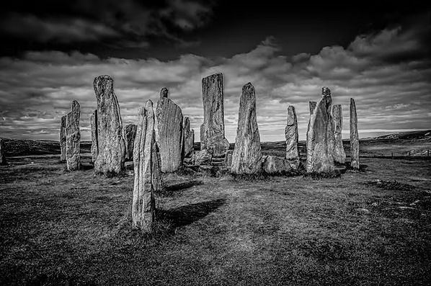
Subscription
Stockton

Camera

Club

Programme

2026 – 2027

www.stocktoncameraclub.co.uk

Welcome to Stockton Camera Club
If you enjoy photography – whether taking photographs or simply looking at them, why not come along to our Club?
We have people of all levels of expertise as members, both experienced and novice photographers. No matter what your favourite subject matter or the equipment you use, be it medium format or compact camera, film or digital, if you enjoy taking or looking at photographs, or want to become more proficient at taking them, you will find something to interest you.
We have a full and varied programme of meetings throughout the year including illustrated talks by leading photographers and competitions where independent judges give advice on our efforts.
Members are encouraged to show their images and to demonstrate new techniques or share problems encountered when trying to enhance those ‘difficult’ images. Many of our more experienced members give help on the various methods of enhancing images by digital means.
The club members welcome everyone who comes along. The centre is open from 7.15 with a 7.30 start. The sessions finish at 9.30 with a ten minute tea break. We look forward to meeting you.

Stockton
Camera
Club

Programme
2023 -2024
www.stockton cameraclub.co.uk

Dave Hudspeth – Colour Image of the Year

Ordinary Member £60
Member and Partner £70
Senior Citizen £50
Junior and Job Seeker Allowance £35

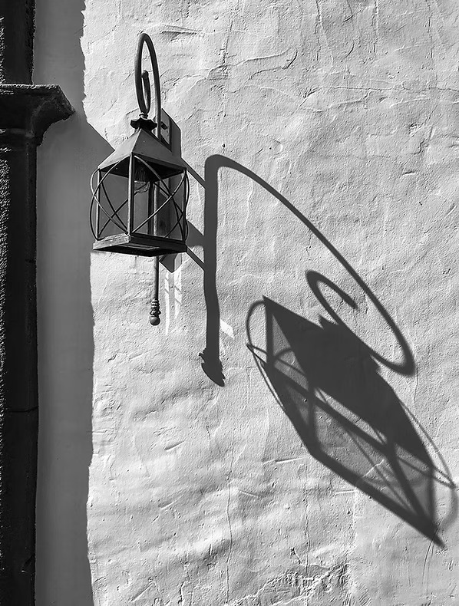
The above subscriptions are inclusive of membership of the NCPF andNYSDPASubscription

Ordinary Member £60
Member and Partner £70
Senior Citizen £50
Junior and Job Seeker Allowance £35

The above subscriptions are inclusive of membership of the NCPF andNYSDPASubscription

Ordinary Member £60
Member and Partner £70
Senior Citizen £50
Junior and Job Seeker Allowance £35

The above subscriptions are inclusive of membership of the NCPF andNYSDPASubscription

Ordinary Member £60
Member and Partner £70
Senior Citizen £50
Junior and Job Seeker Allowance £35

Qrdinary Member £60
Member and Partner £70
Senior Citizen £50
Junior and Job Seeker Allowance £35

The above subscriptions are inclusive of NYSDPA and NCPF Subscriptions

The above subscriptions are inclusive of memberip

