September 2023
Programme 2023 - 2024
6^{h} | Opening night drinks and nibbles |  |  |  |  | Presentation -members show a sample of their images
16th | Practical Night
20th | David Brown |  |  |  |  | Iceland – a photographers dreamland
27th | First competition - open |  |  |  |  | Judge – Alan Wilson ARPS, AFIAP,
October 2023
4th |  | A tribute to Bill Stephenson |  |  |  | A chance to see a selection of Bills work with Dave Phillips
11th |  | Print Clinic |  |  |  | Member to bring in work for discussion in small groups
18th |  | Interclub Competition with Hartlepool |  |  |  | Judge - Alan Chambers Hosted by Stockton Camera Club
25th |  | 2nd Competition Theme – ‘People at Work’ |  |  |  | Judge – Dave Murell
November 2023
1st |  | Linda Golightly |  |  |  | Finding your photographic style-a personal journey  www.whickhamphotographic.club/project/lynda-golightly/
8th |  | John Webster |  |  |  | Light and Inspiration  www.johnwebsterphotography.co.uk
15th |  | Norton Tankard Competition |  |  |  | Judge – Dave Coates
22nd |  | George Robertson |  |  |  | The throne Room of the Mountain Gods  https://georgerobertsonphotography.com
29th |  | John Birch |  |  |  | Wildlife Photography  https://www.johnbirchphoto.com
December 2023
6th |  | NYSDPA Inter Club Portfolio
13th |  | Christmas Party |  |  | Party Quiz
January 2024
3rd | 3rd Competition - open |  |  |  | Judge – Keith Blundy
10th | Processing Circle -a  practical exercise in digital  interpretation /manipulation |  |  |  | Members have the opportunity to edit other members RAW files and present the results to the group
17th | NYSDA silver salver portfolio
24th | It’s a Knock Out |  |  |  | Members to submit 4 prints to be judged by members in a knockout competition
February 2024
31st |  | 4th Competition Theme – ‘Still Life’ |  |  | Judge – Martin Vickerman
7th |  | Joe Houton |  |  | ‘I didn’t know lightroom could do that’ via Zoom at Elmwood
14th |  | Club AV Night |  |  | Members bring in their own presentations.
21st |  | NCPF portfolio - |  |  | A selection of images from recent competition
March 2024
28th |  |  | 5th Competition - open |  | Judge – Keith Archer
6th |  |  | Paul Forster |  | Rock Coastline  https://www.pwforster.co.uk
13th |  |  | Bingo Challenge |  | AV presentation of members work on randomly selected themes
20th |  |  | Dave and Sheila Coates |  | Rambling About  www.davecoates.org.uk
27th |  |  | Image of the Year Competition |  | Judge – Stephen Fowler
April 2024
3rd | AGM
10th | Annual Dinner |  |  | Venue to be confirmed  Matt Kerridge – Digital image of the year
Competition details
 |  | Date for Entries |  |  | Judging Date
1st Competition
 |  | 6/09/2023 |  |  | 27/09/2023
Interclub Competition
 |  | 27/9/2023 |  |  | 18/10/2023
2nd Competition – theme ‘People at Work’
 |  | 4/10/2023 |  |  | 25/10/2023
Norton Tankard
 |  | 25/10/2023 |  |  | 15/11/2023
3rd Competition
 |  | 29/11/2023 |  |  | 3/01/2024
4th Competition – theme ‘Still Life’
 |  | 10/01/2024 |  |  | 31/01/2024
5th Competition
 |  | 7/02/2024 |  |  | 28/02/2024
Print and Digital Image of the Year
 |  | 6/03/2024 |  |  | 27/03/2024
Hand in date for: NYSDPA Competition TBA
NCPF Competition TBA
Meetings are held between 7.30 and 9.30 at:
Room 3
Elmwood Community Centre
53 Darlington Road
Hartburn
Stockton-on-Tees
TS18 5EP

For more details call Steve Smith on 01642 588604 or email on s.smith440@me.com
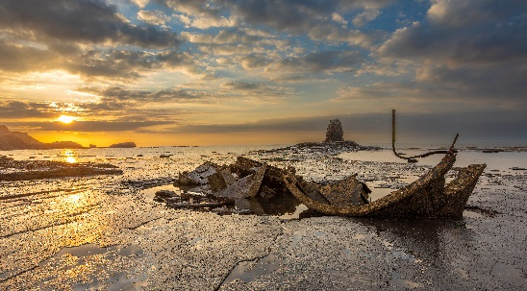

Club Officers
Life Vice President
Chair | Steve Smith LRPS
Vice Chair | Sarah Hillier LRPS
Secretary | Sue Tyerman LRPS
Treasurer | Sue Tyerman LRPS
Competition Secretary | Brian Swales LRPS
Programme Secretary | Steve Smith LRPS
Publicity Officer | Vacancy
Committee Members | Ken Messham
 | Carmel Morris ARPS
 | Matt Kerridge
Ladder Competition Secretary | Darren Richardson
Projectionist | Ken Messham
Deputy Projectionist | Andy Gunn
NCPF Representative | Darren Richardson
NYSDPA Representative | Andy Gunn
Webmaster | Brian Swales LRPS
Webmaster | Sue Tyerman LRPS
To contact the club:
Call Steve Smith on 01642 588604
Email s.smith440@me.com
Stockton
Camera
Club

Programme
2023 -2024
www.stockton cameraclub.co.uk
Welcome to Stockton Camera Club
If you enjoy photography – whether taking photographs or simply looking at them, why not come along to our Club?
We have people of all levels of expertise as members, both experienced and novice photographers. No matter what your favourite subject matter or the equipment you use, be it medium format or compact camera, film or digital, if you enjoy taking or looking at photographs, or want to become more proficient at taking them, you will find something to interest you.
We have a full and varied programme of meetings throughout the year including illustrated talks by leading photographers and competitions where independent judges give advice on our efforts.
Members are encouraged to show their images and to demonstrate new techniques or share problems encountered when trying to enhance those ‘difficult’ images. Many of our more experienced members give help on the various methods of enhancing images by digital means.
The club members welcome everyone who comes along. The centre is open from 7.15 with a 7.30 start. The sessions finish at 9.30 with a ten minute tea break. We look forward to meeting you.
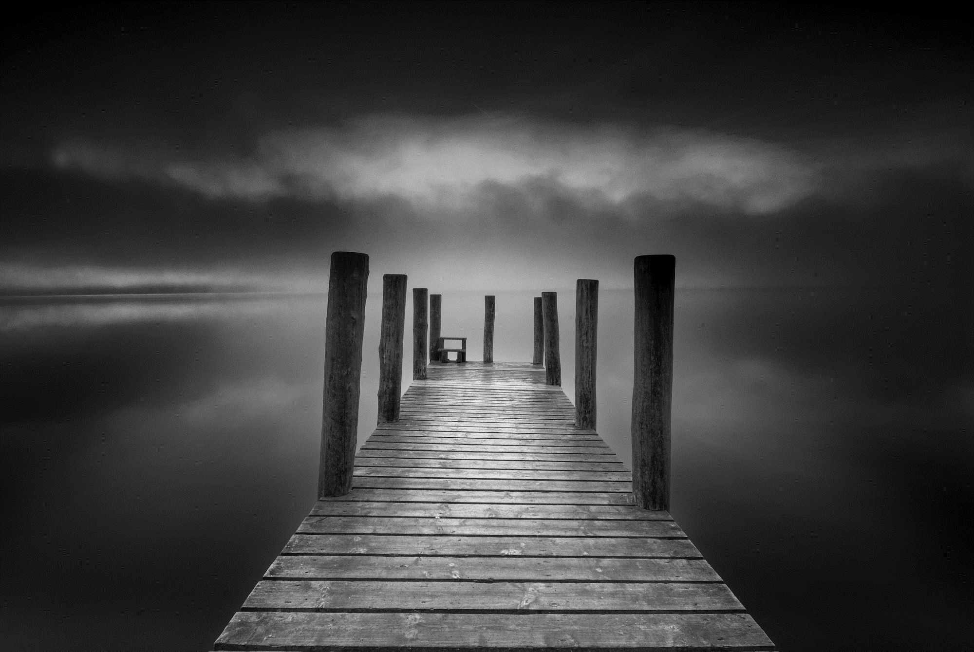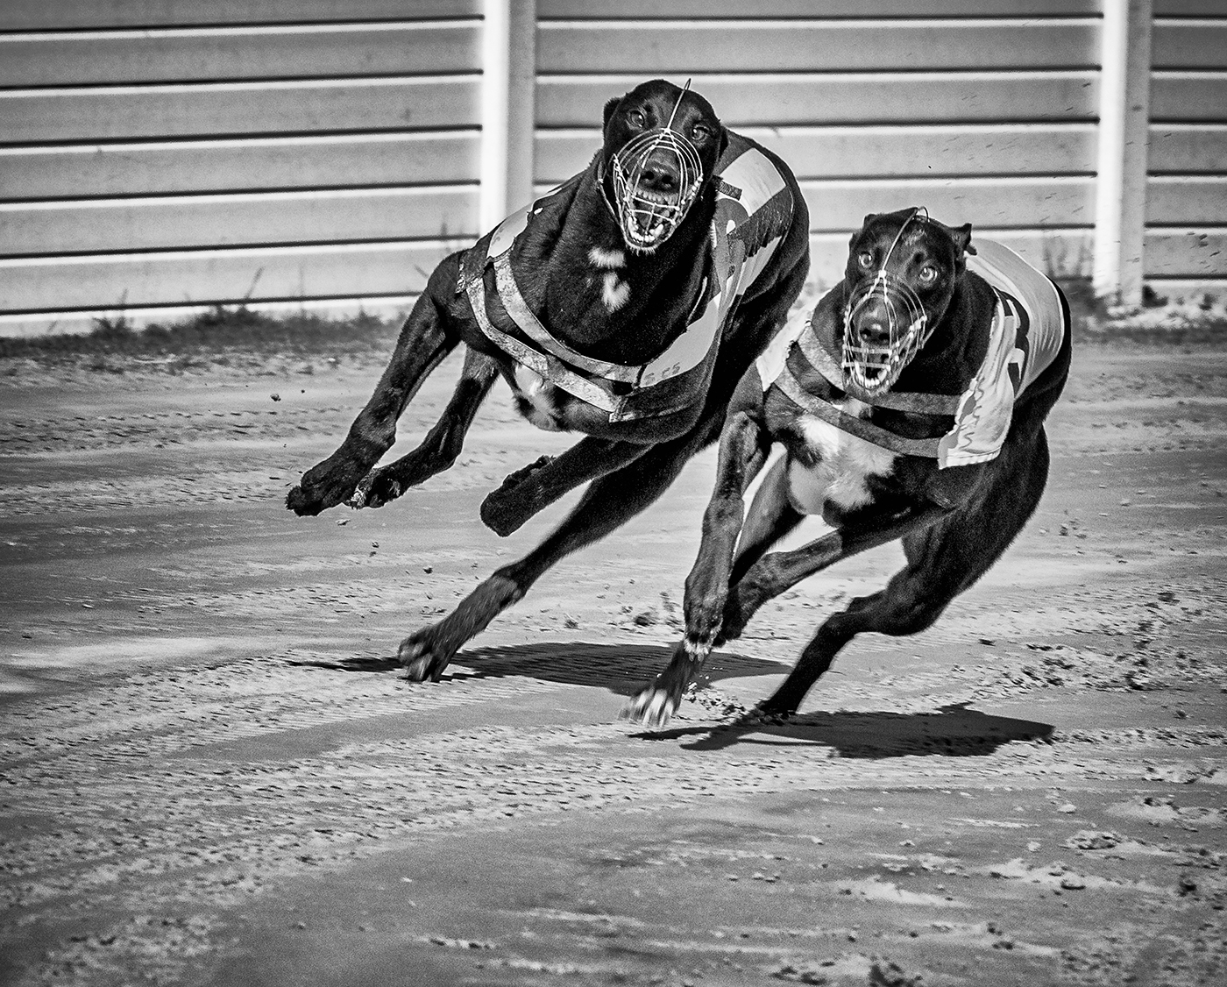

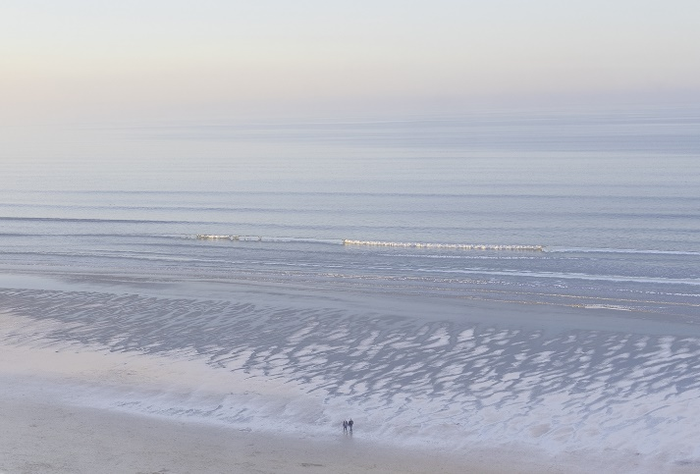
Subscriptions
Ordinary Member £50.00
Member and Partner £60.00
Senior Citizen £40.00
Junior and Job Seekers Allowance £26.00
The above subscriptions are inclusive of membership of the NCPF and NYSDPA

Sarah Hillier – Colour Image of the year 2022-2023
Dave Hudspeth - Monochrome Image of the Year 2022-2023

